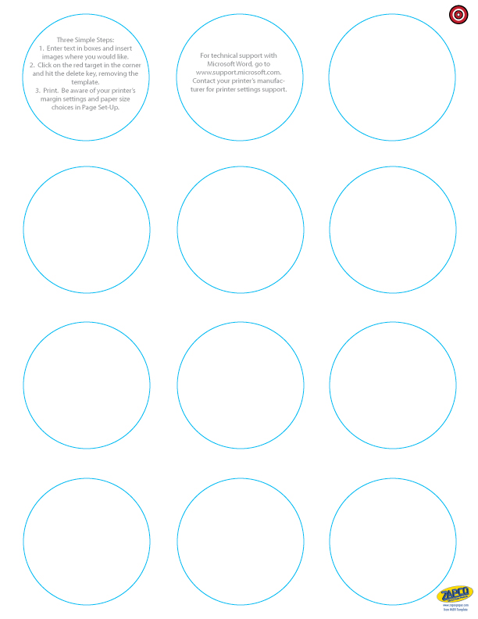

Enter Text and Pics Here

Enter Text and Pics Here

Enter Text and Pics Here

Enter Text and Pics Here

Enter Text and Pics Here

Enter Text and Pics Here

Enter Text and Pics Here

Enter Text and Pics Here

Enter Text and Pics Here

Enter Text and Pics Here